Topic 2 Homework
Question 2: Morphological Classification

2. Classification
Read deVaucouleurs’ article in Handbuch der Physik (p281 – 284 and p287 – 303) so that you become familiar with his classification scheme.

Classify the following 14 galaxies. For each galaxy give a brief justification of your assigned type.

Galaxy 1: SDSS  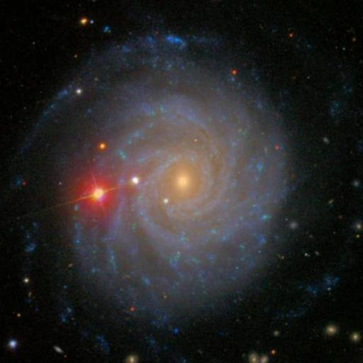 | Galaxy 1: Blue  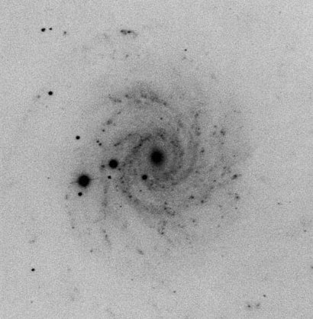
Galaxy 2: SDSS  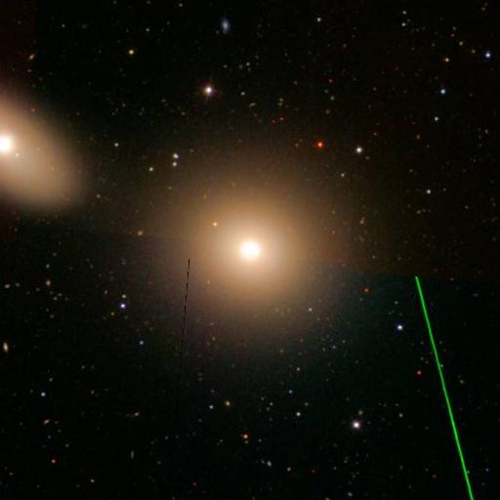 | Galaxy 2: Blue  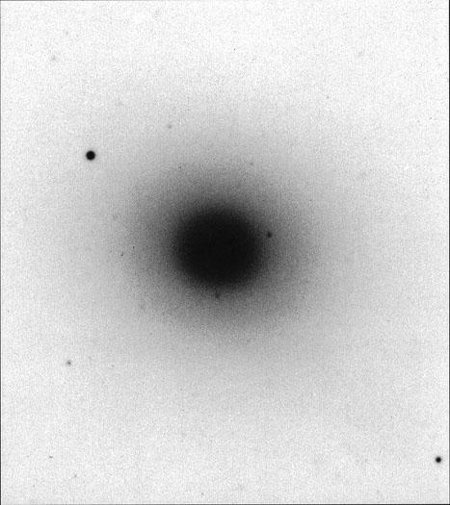
Galaxy 3: SDSS  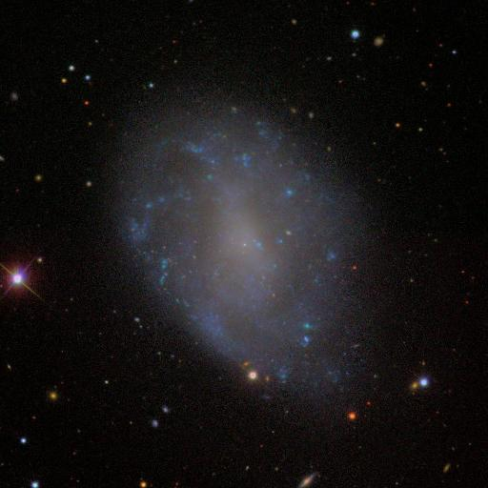 | Galaxy 3: Blue  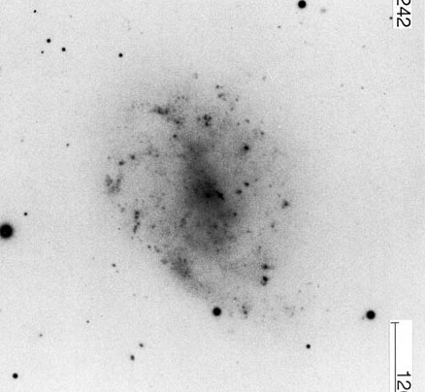
Galaxy 4: SDSS  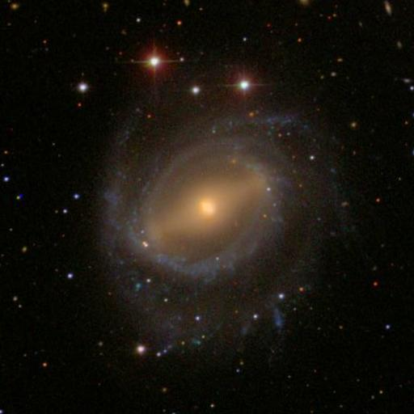 | Galaxy 4: Blue  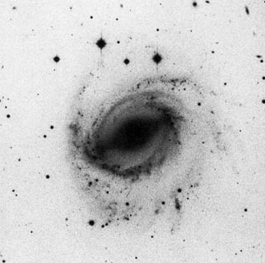
Galaxy 5: SDSS  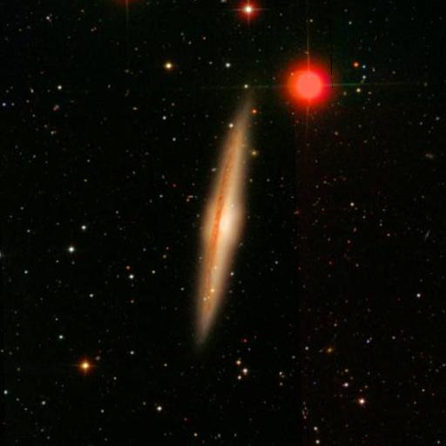 | Galaxy 5: Blue  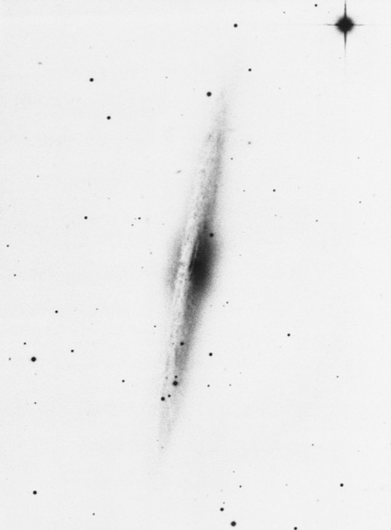
Galaxy 6: SDSS  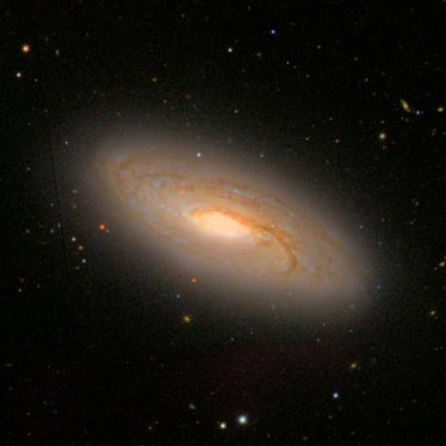 | Galaxy 6: Blue  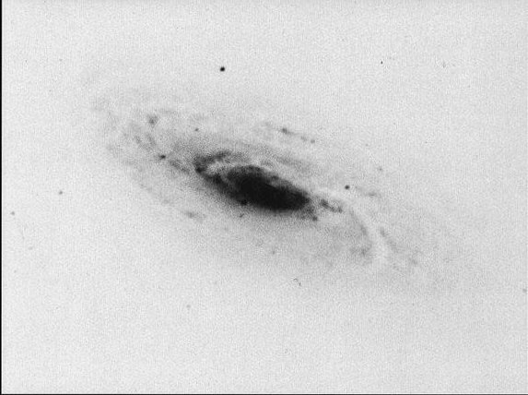
Galaxy 7: SDSS  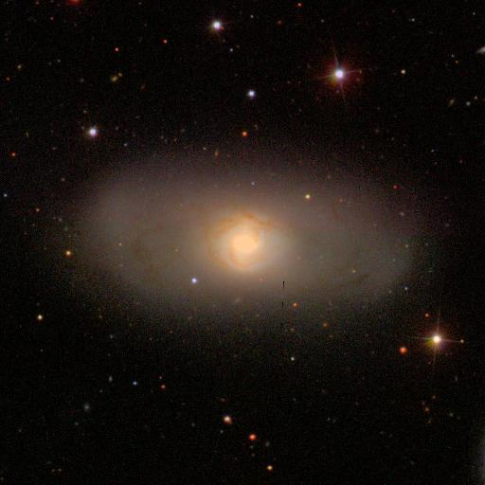 | Galaxy 7: Blue  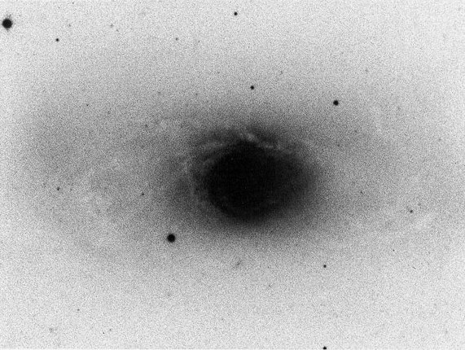
Galaxy 8: SDSS  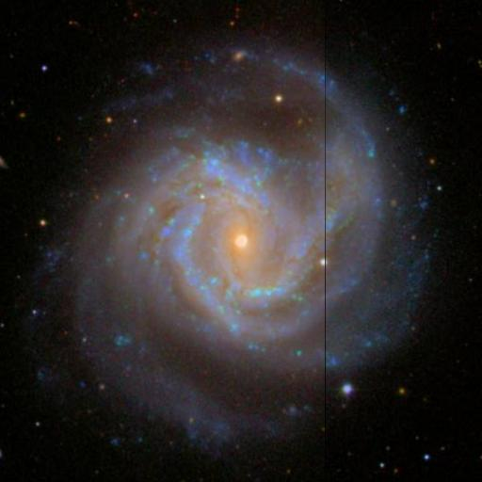 | Galaxy 8: Blue  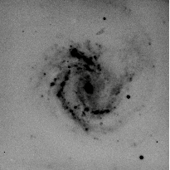
Galaxy 9: SDSS  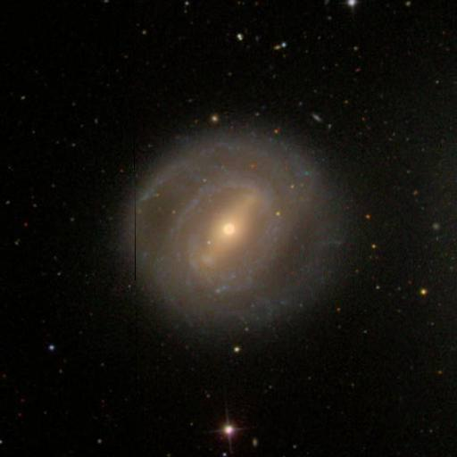 | Galaxy 9: Blue  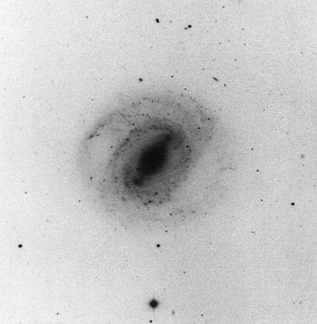
Galaxy 10: SDSS  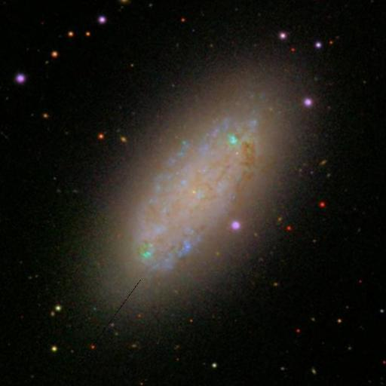 | Galaxy 10: Blue  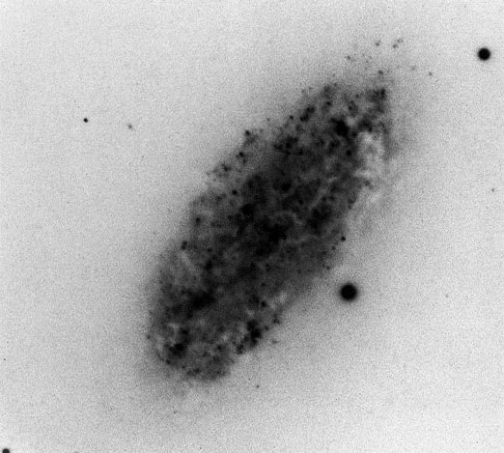
Galaxy 11: SDSS  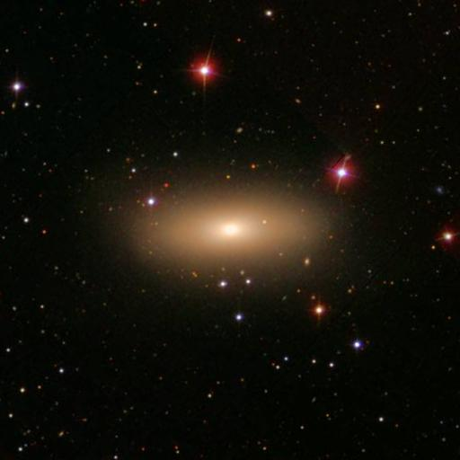 | Galaxy 11: Blue  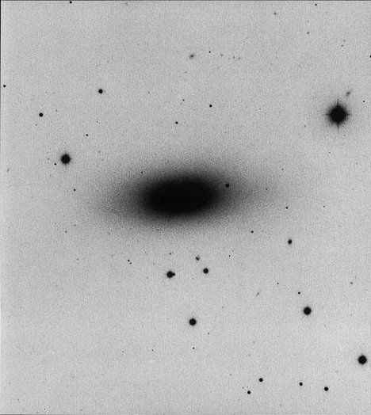
Galaxy 12: SDSS  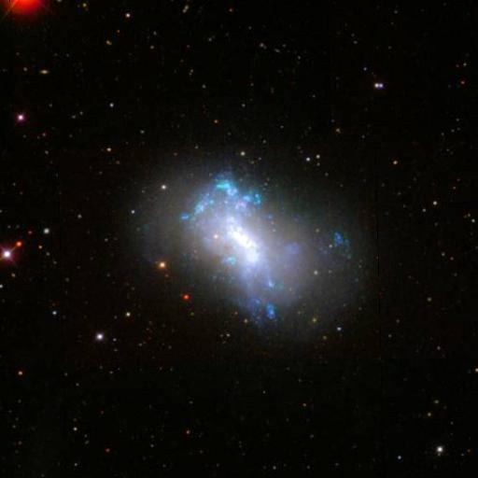 | Galaxy 12: Blue  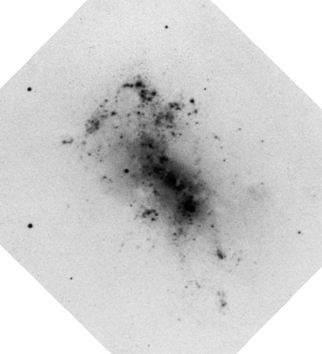
Galaxy 13: SDSS  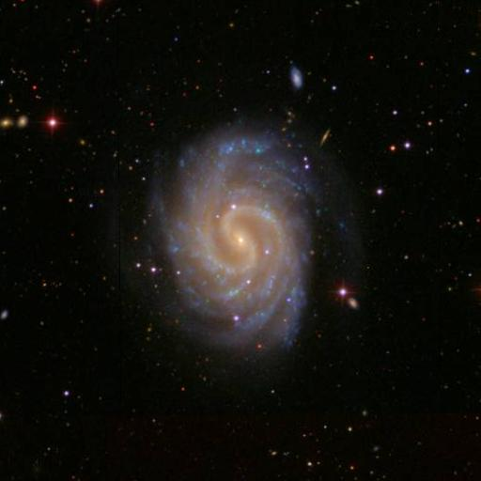 | Galaxy 13: Blue  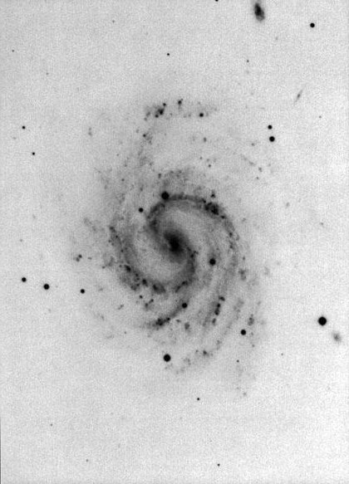
Galaxy 14: SDSS  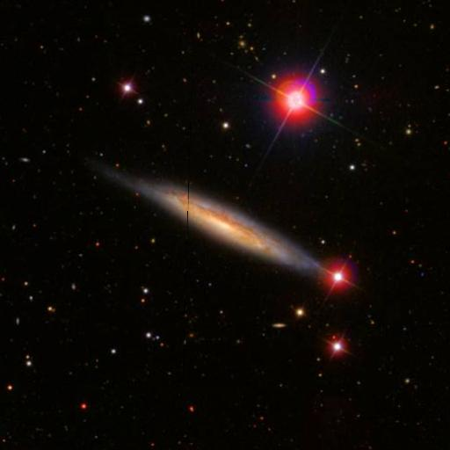 | Galaxy 14: Blue  